
Cloud Computing Lab

Submitted to:
Engr. Muhammad Shoaib

Submitted by:
Hania Akbar

Reg no:
2023-BSE-026

Section:
A

Lab 6 – Linux Users, Groups, Permissions, Pipes, and Bash Scripting

Task 1 – Switch to root with su - and back to a normal user
- Set a root password (Ubuntu root is disabled by default; this enables su - temporarily for the lab):

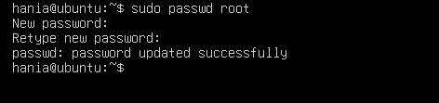
- Switch to root and verify:

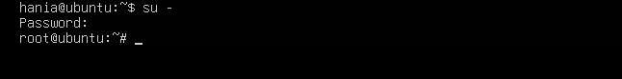

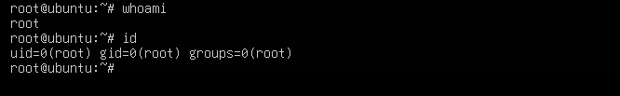

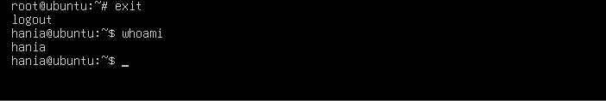

Task 2 – Create user tom and verify in passwd/group/shadow
- Create user tom (interactive, sets password and home directory):

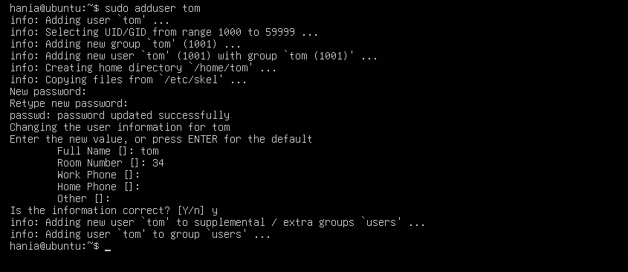

- Verify tom in system files (view and visually confirm presence):

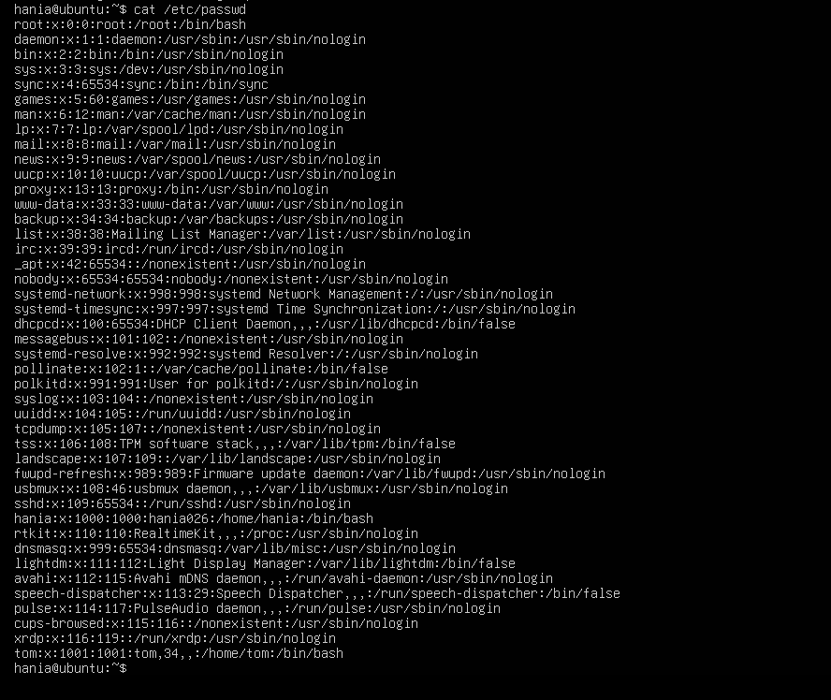

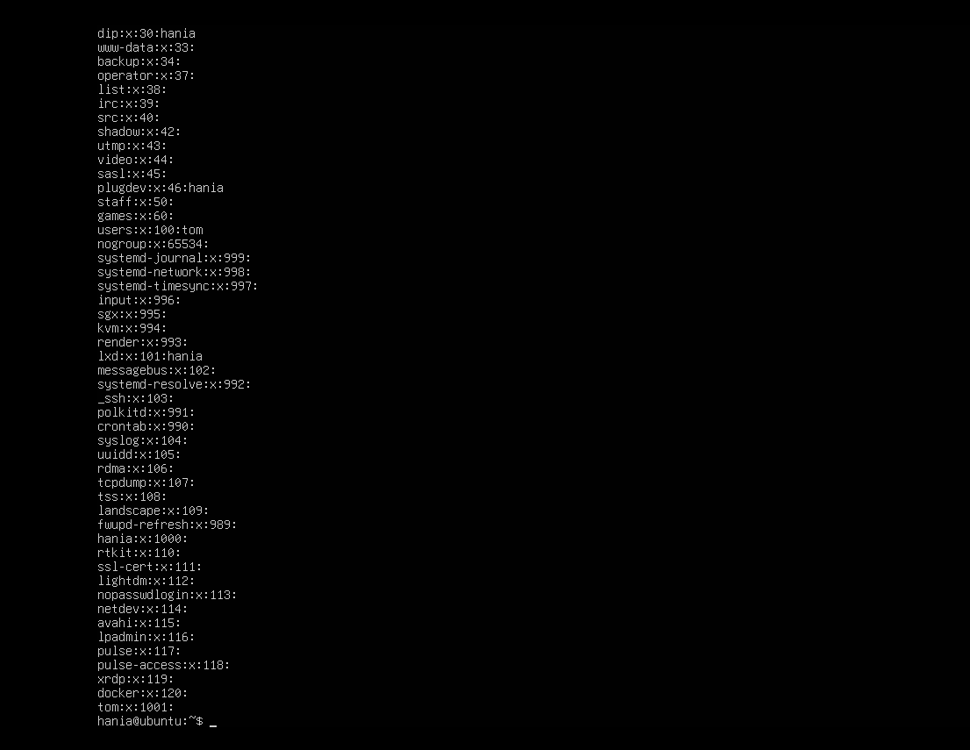

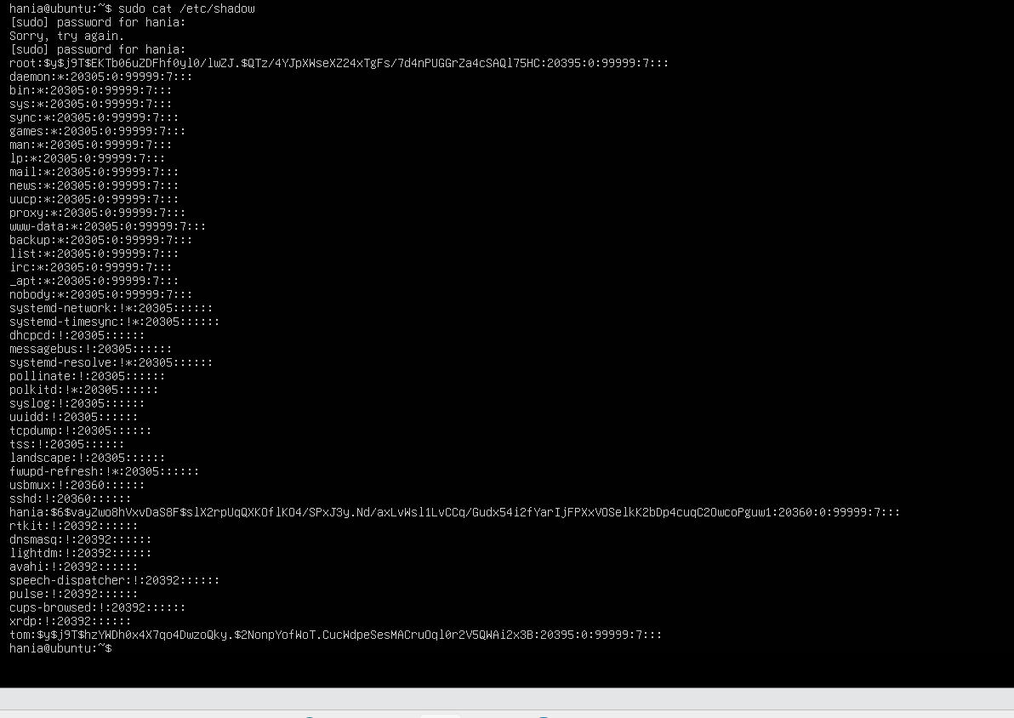

Task 3 – Create groups; change tom’s primary and secondary groups
- Create groups and verify by viewing /etc/group (visually confirm entries exist):


- Change tom’s primary group to designer and verify:
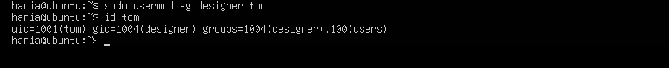
- Add secondary groups developer and devops to tom and verify:
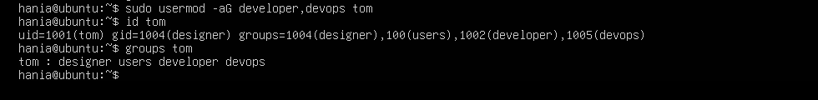

- Replace all secondary groups so only tom (user’s own group) remains and verify:
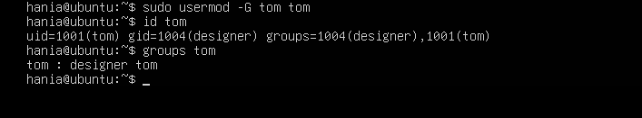

Task 4 – Create/delete users (Jerry, Scooby) and groups (jolly, anime)
- Create users:
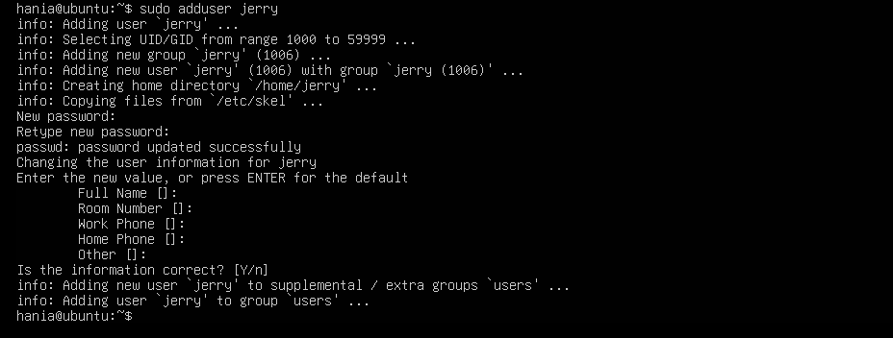
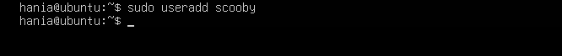
- Try to log in as Scooby immediately (expected authentication failure because there is no password yet):
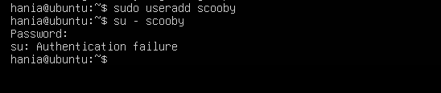
- Set a password for Scooby:
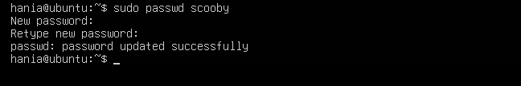
- Try logging in as Scooby again (home directory still missing; expect a message such as “No directory, logging in with HOME=/”):
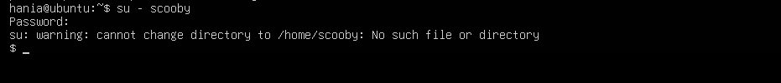
- Show that Scooby’s home directory does not exist yet and what /etc/passwd says:
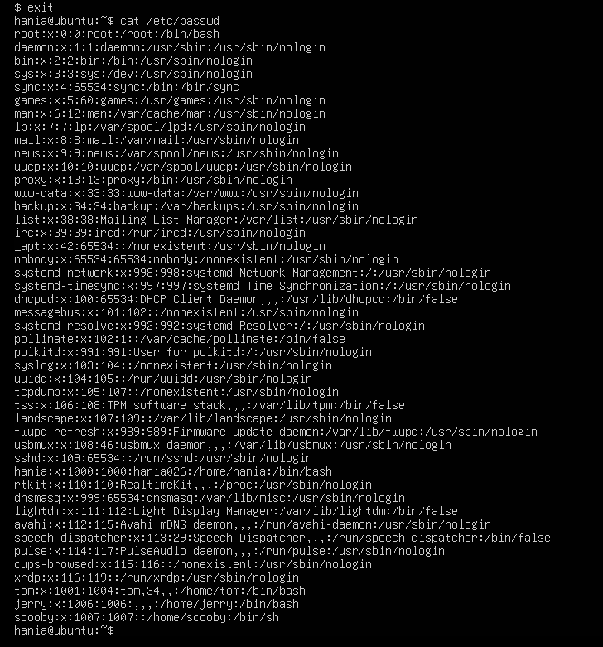

- Manually create Scooby’s home directory and set proper ownership and permissions:
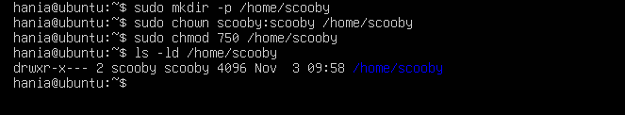
- Log in as Scooby again and verify you land in the correct home directory:
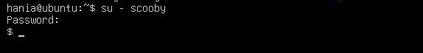
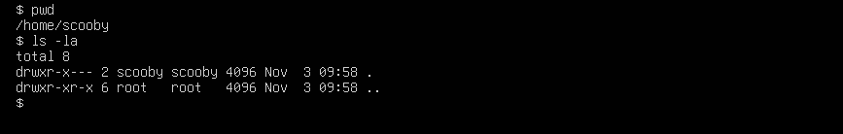
- Verify users in system files and observe shell of Scooby:
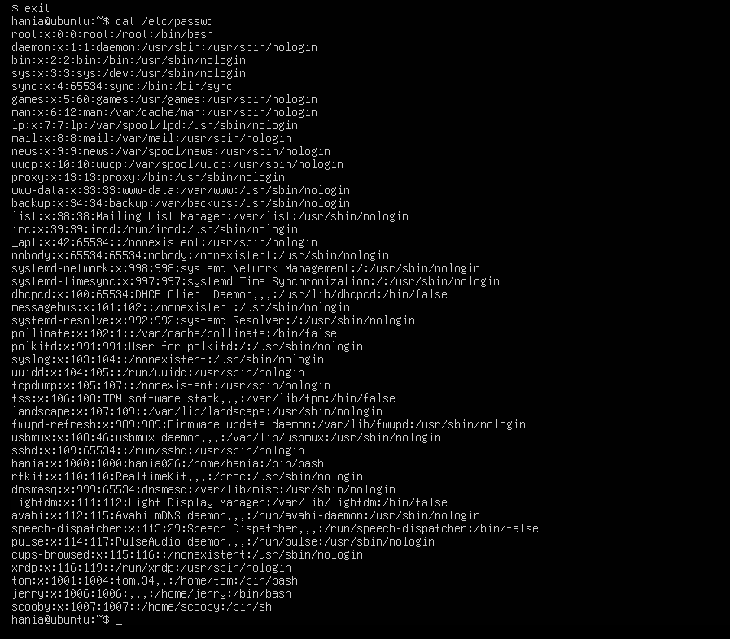
- Change the shell from /bin/sh to /bin/bash
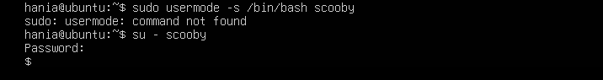
- Create groups:
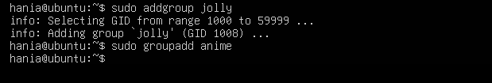
- Verify groups:
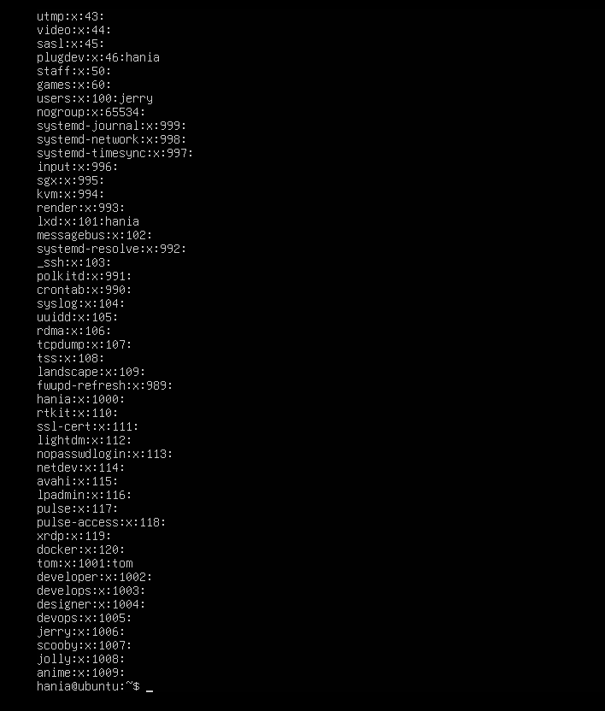
- Delete groups and users:
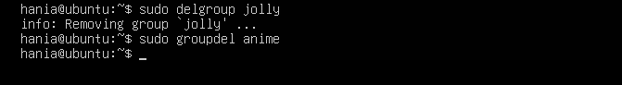
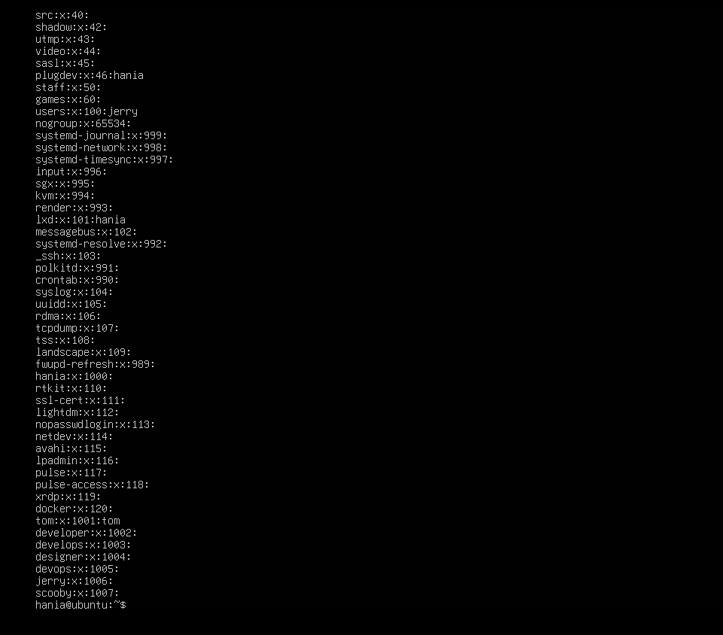

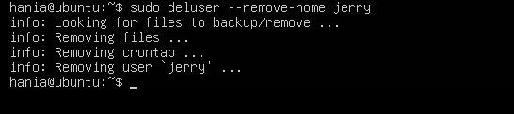

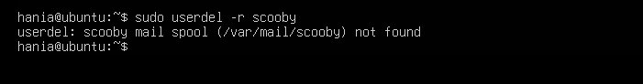
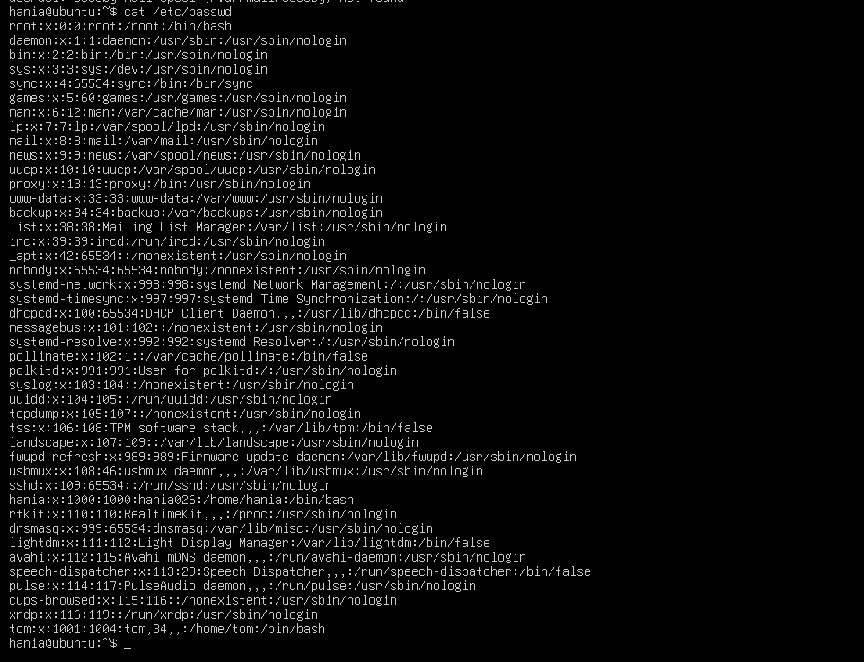

Task 5 – Create user Student; create files; set owner/group; identify file types
- Create Student:
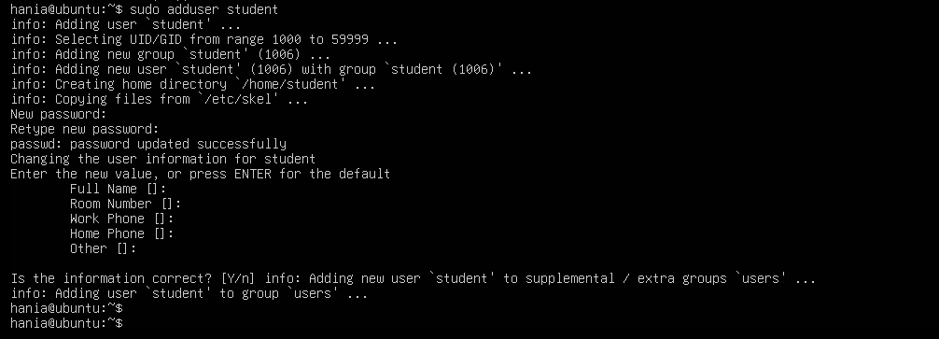
- Switch to Student and create files:
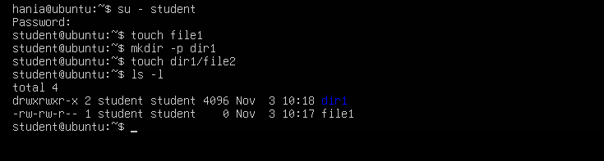

- Change owner then group for file1 (separate commands):
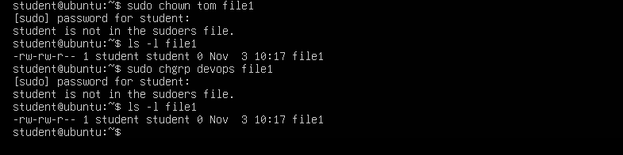

- Identify files/directories and show /dev/null:
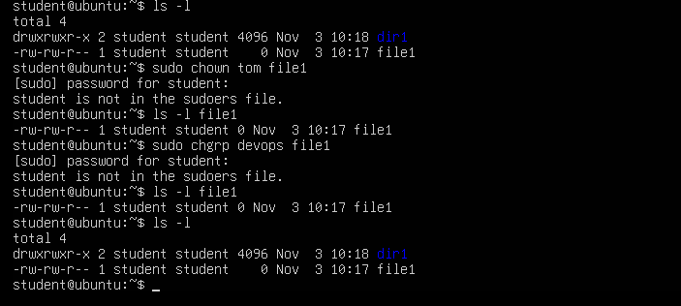
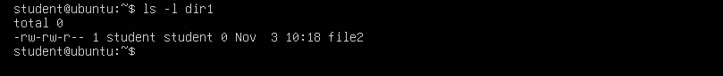
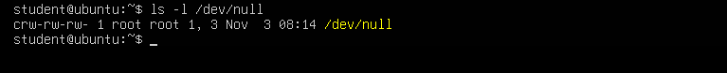

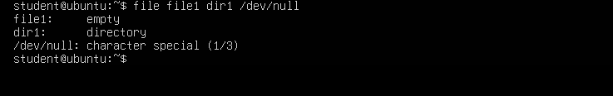

- Exit Student:
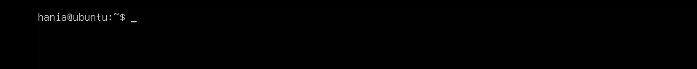

Task 6 – Change permissions using symbolic mode

- Ensure Student and file present:
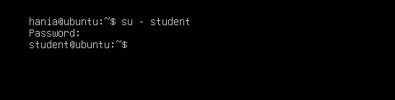
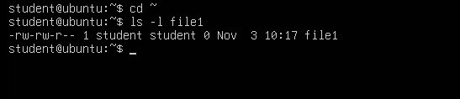
- Remove all permissions:
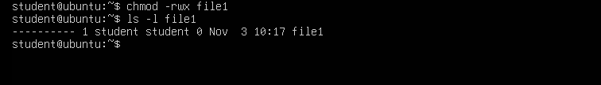
- Add read to all:
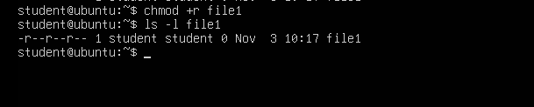
- Add execute to user:
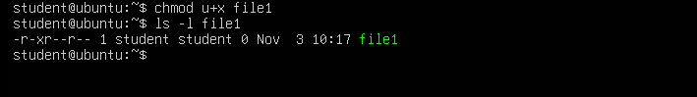
- Add write to user and group:
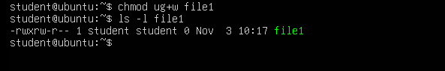
- Remove all permissions (explicit):
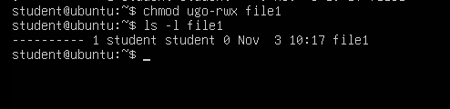

Task 7 – Change permissions using “set” symbolic form (u= g= o=)
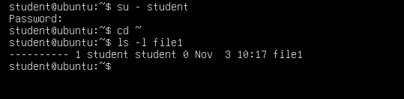
- Set all to rwx:
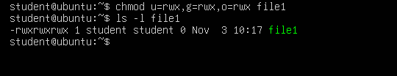
- Remove execute from group and others:
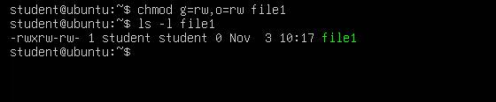
- Remove all permissions:
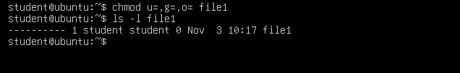

Task 8 – Change permissions using numeric (octal) mode

1.
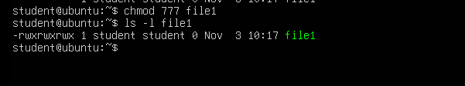
2.
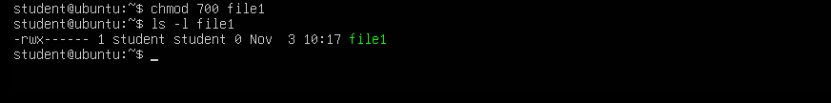
3.
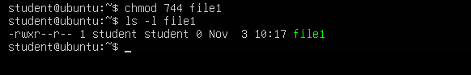
4.
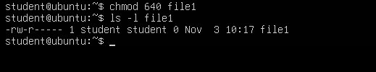
5.
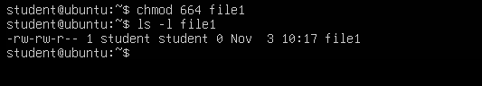
6.
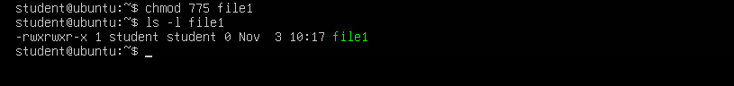
7.
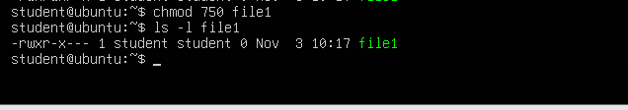

Task 9 – Practice pipes, pagers, grep, and redirects with /var/log/syslog
1.
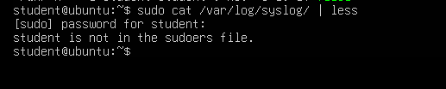
2.
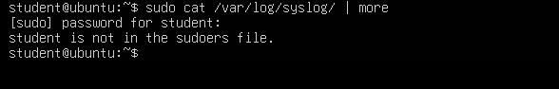
3.
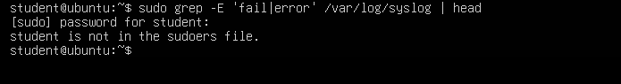
4.
redirect
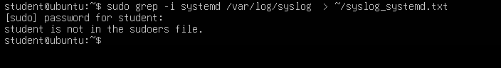
Append
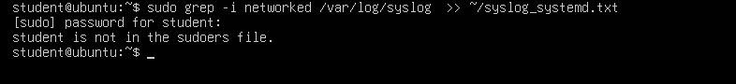
Alternative (journalctl) if needed:
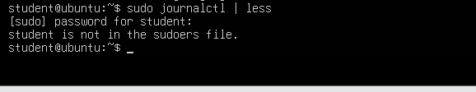

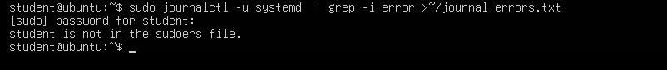

Task 10 – Script setup.sh – variables, command substitution, file/dir checks, permissions (use vim)
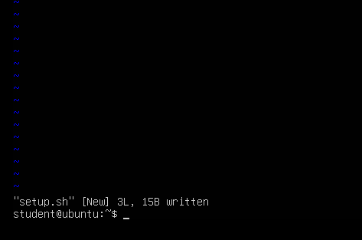



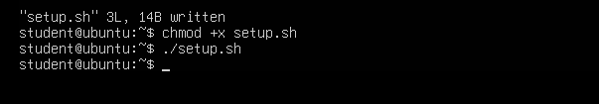
- Define variable var1 and echo it
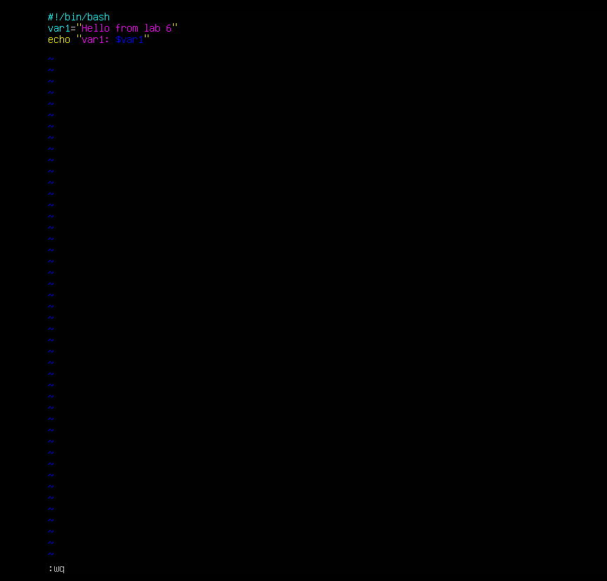

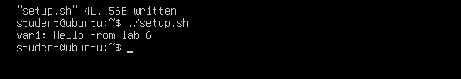

- Save output of ls -l into variable allFiles and echo it
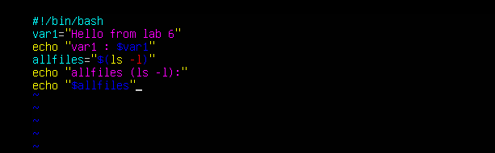
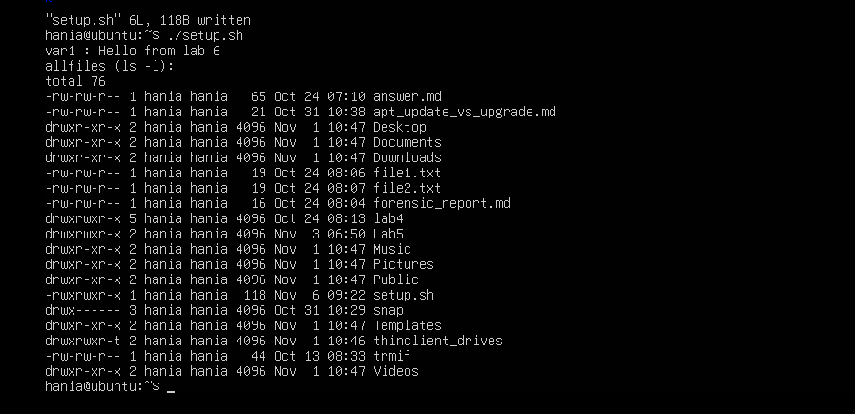

- If directory dir1 exists echo a message; else create it

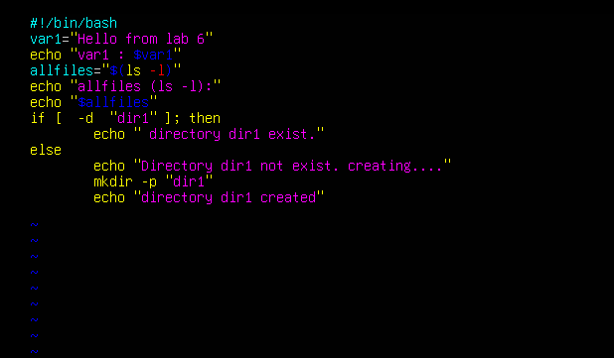
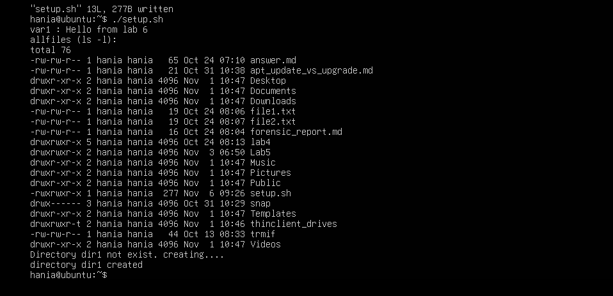
- If file dir1/file2 does not exist, create it
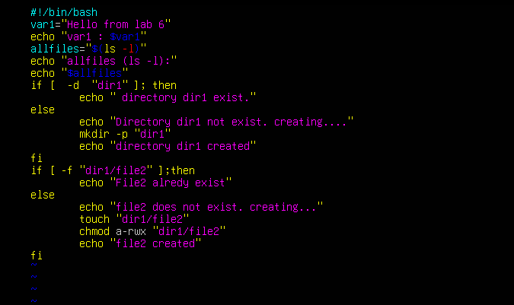

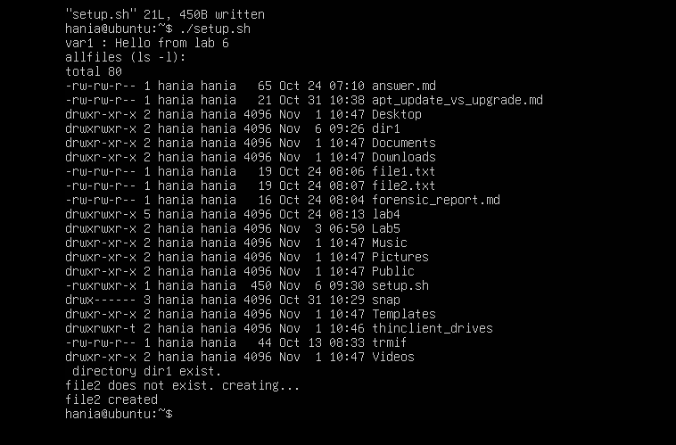
- Check read, write, execute permissions on dir1/file2; grant missing user perms and show final ls
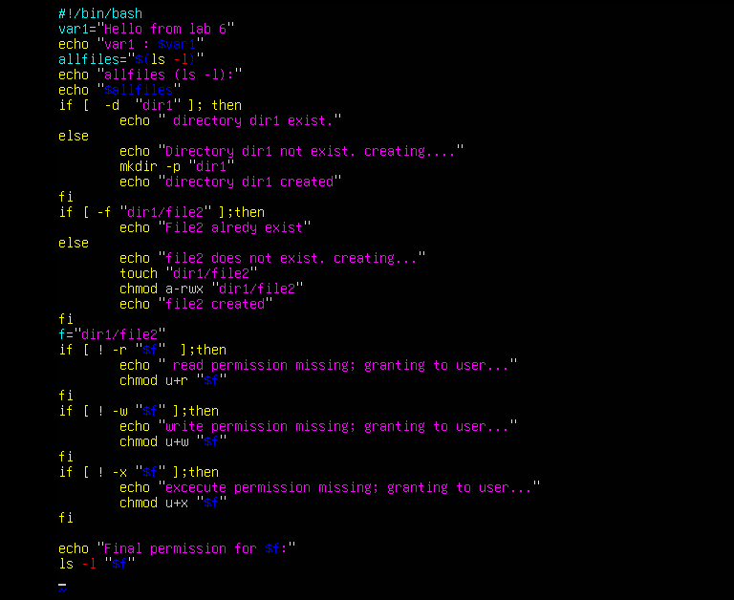
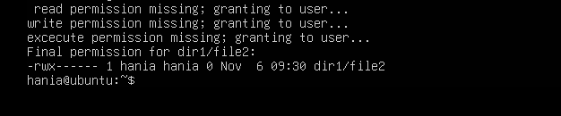

Task 11 – Script setup.sh – argument comparisons (eq, ne, gt, lt, ge, le) and string checks
- create file with shebang and set num and str variables

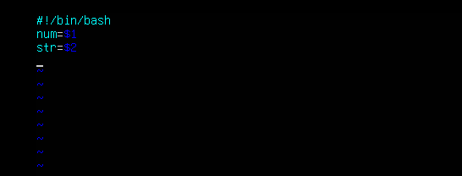
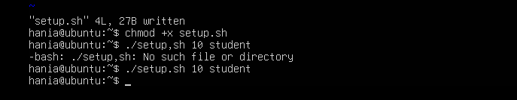
- add the -eq test (equal)
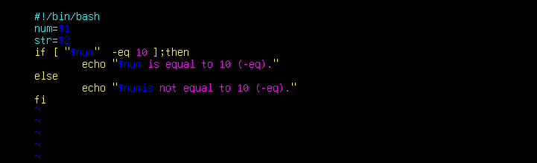
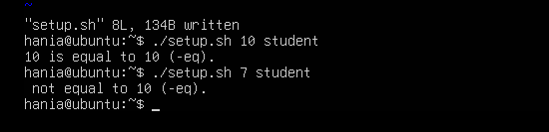

- add the -ne test (not equal)
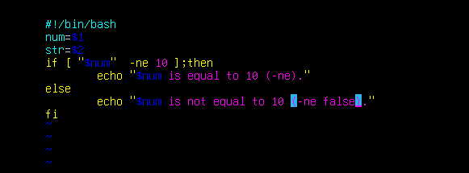
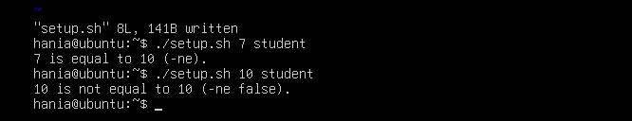
- add the -gt test (greater than)
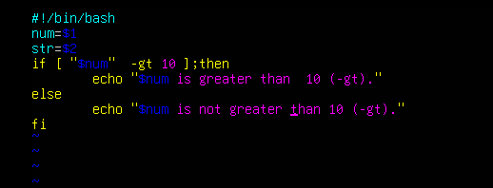
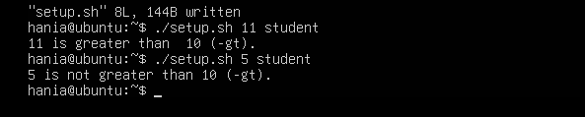
- add the -lt test (less than)

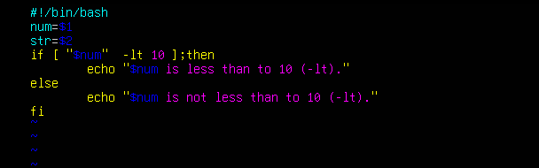
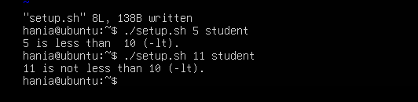
- add the -ge test (greater than or equal)
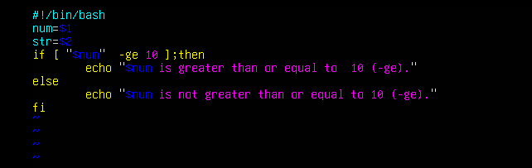
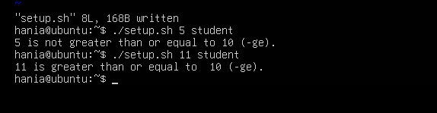
- add the -le test (less than or equal)
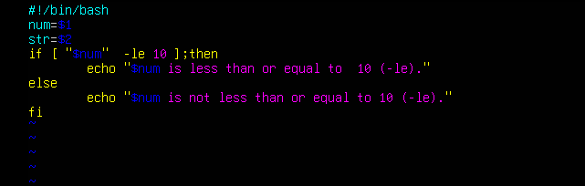
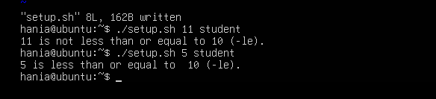
- string equality test ( = )
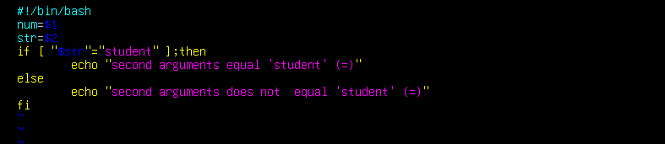
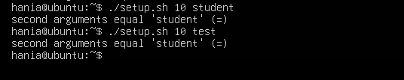
- string inequality test ( != )
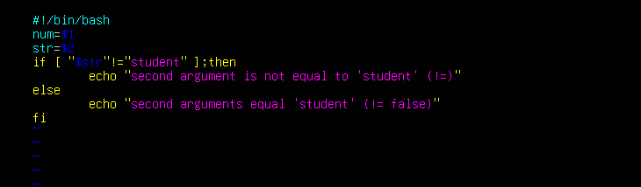
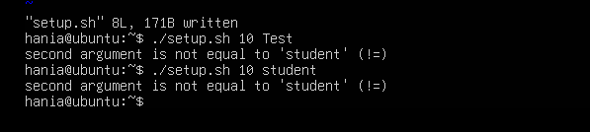
- check if second argument is empty (zero-length)
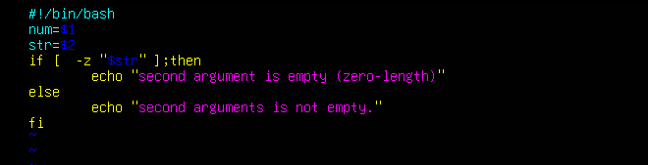
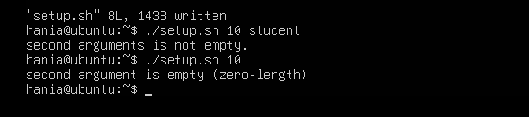

Task 12 – Script setup.sh – print all arguments with a for loop
- Create the script with shebang and basic structure
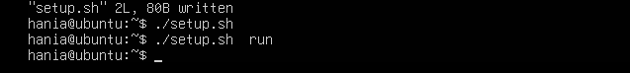
- Append the for loop using $* and print each argument
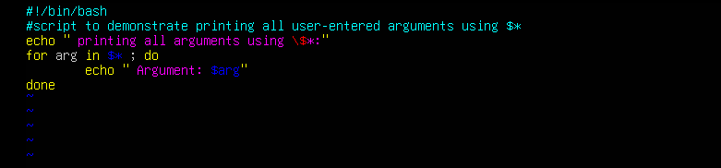
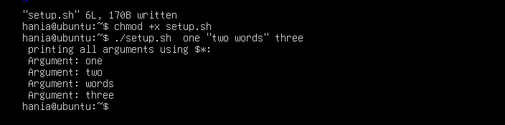

Task 13 – Script setup.sh – while loop summation and functions
- Add the shebang line

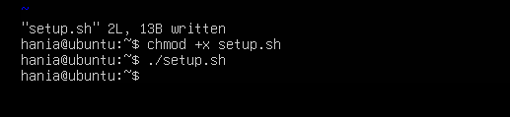
- Add the while-loop summation (interactive)
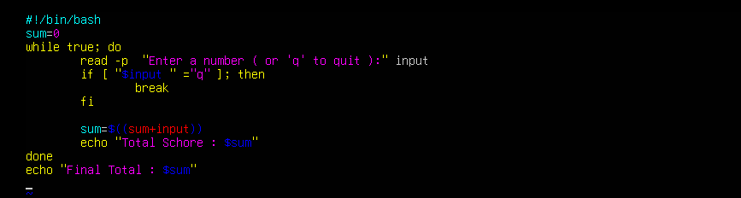
3
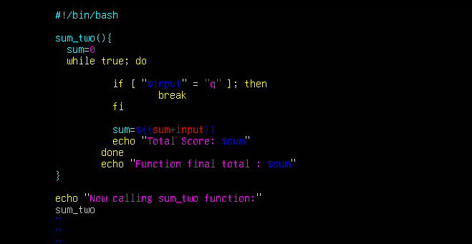
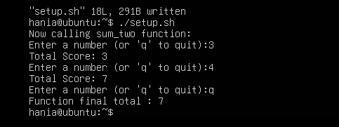
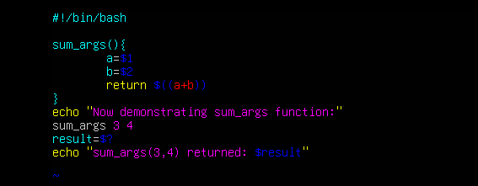
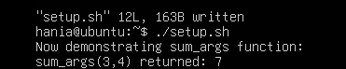

Task 14 – Codespaces GUI — fork repo, run start-desktop.sh, open VNC, stop GUI

